
International School

Capstone Project 2
CMU-SE 451

Database Design Document
Version 2.0
Date: Feb 26, 2022

Pet Care And Supervision Services

Submitted by

Truong Le Dai
Nguyen Hong Hieu
Tran Thi Chung
Le Quang Van

Approved by
Dr. Nguyen Tan Thuan

Proposal Review Panel Representative:

Name Signature Date

Capstone Project 1- Mentor: Dr. Nguyen Tan Thuan

Name Signature Date
PROJECT INFORMATION

Project acronym | PetCare
Project Title | Pet Care And Supervision Services
Start Date | 26 Feb 2022 | End Date | 26 Feb 2022
Lead Institution | International School, Duy Tan University
Project Mentor | Dr. Nguyen Tan Thuan
Scrum master / Project Leader & contact details | Truong Le Dai  Email:daicatimmai123v30@gmail.com  Tel: 0774443926
Partner Organization
Project Web URL
Team members | Name | Email | Tel
24211407122 | Truong Le Dai | daicatimmai123v30@gmail.com | 0799400038
24211205523 | Nguyen Hong Hieu | nguyenhonghieuit@gmail.com | 0777903474
24201402277 | Tran Thi Chung | tranchung10a3@gmail.com | 0945228146
24211401402 | Le Quang Van | vanlequang00@gmail.com | 0898163596

Database Design Document

Document Title | Database Design
Reporting Period | Feb 2022
Author(s) & project | Truong Le Dai, Scrum Master
Role | Nguyen Hong Hieu | Member
 | Tran Thi Chung | Member
 | Le Quang Van | Member
Date | 26 Feb 2022 | Filename |  | C2SE.27-Database Desing-PetCare.doc
URL
Access | Project and CMU Program

REVISION HISTORY

Version | Date | Comments | Author | Approval
1.0 | 22 Sept 2021 | Initial | C1SE.19 Team | Dai
1.1 | 23 Sept 2021 | Create table relationship database | C1SE.19 Team | Dai
1.2 | 24 Sept 2021 | Create entity relationship database | C1SE.19 Team | Dai
2.0 | 26 Feb 2022 | Update database document | C2SE.27 Team | Team

DOCUMENT APPROVALS

The following signatures are required for approval of this document
Dr. Nguyen Tan Thuan  Mentor |  | Date:
Truong Le Dai  Scrum Master |  | Date:
Nguyen Hong Hieu  Pruduct Owner |  | Date:
Tran Thi Chung  Member |  | Date:
Le Quang Van  Member |  | Date:

Table Of Content
1. Introduction 6
1.1. Purpose 6
1.2. Goal 6
1.3. Scope 6
1.4. Data storage platforms 6
1.5. Definition, Acronyms and Abbreviations 6
2. Database Design 7
2.1. Table Overview 7
2.2. Entity Relationship Diagram 8
2.3. Relationship Diagram 9
3. References 25

Introduction

Purpose
Place information system’s database design document describes structure of database and file structure of system. Database Design document will introduce all attribute the System that will help developer and tester base on this design to implement and test.

Goal
Database design is a collection of steps that help create, implement, and maintain a business's data management systems. The primary purpose of designing a database is to produce physical and logical models of designs for the proposed database system.

Scope

Data storage platforms
- Data of application is stored in Mongo database.
- A record in MongoDB is a document, which is a data structure composed of field and value pairs. MongoDB documents are similar to JSON objects. The values of fields may include other documents, arrays, and arrays of documents

Definition, Acronyms and Abbreviations
Abbreviations | Description | Comment
PK/FK | Primary/ Foreign Key | Use to indicate a file is a Primary or Foreign key in a table
ERD | Entity Relationship Diagram | Show the relationship between entities in the system

Database Design

Table Overview
No. | Table name | Short Description
1 | Owner | This table shows all information of Owner
2 | Numberphone_Authentication | This table shows all information of Numberphone_Authentication
3 | Vet_Doctor | This table shows all information of Vet_Doctor
4 | Account | This table shows all information of Account
5 | Clinics | This table shows all information of Clinics
6 | Image_Clinics | This table shows all information of Image_Clinics
7 | Appointments | This table shows all information of Appointment
8 | Messenger | This table shows all information of Messenger
9 | Image_Messenger | This table shows all information of Image_Messenger
10 | Pets | This table shows all information of Pets
11 | Image_Pet | This table shows all information of Image_pet
12 | Illness | This table shows all information of Illness
13 | Calalog_Illness | This table shows all information of catalog’s Illness
14 | Image_Illness | This table shows all information of Illness’s image
15 | Chat | This table shows all information of Chat
16 | Review | This table shows all information of Review
17 | Notification | This table shows all information of Notification.
18 | Schedule | This table shows all information of Schedule.
19 | Liquidation | This table shows all information of Liquidation.
20 | Image_Liquidation | This table shows all information of Image Liquidation.
21 | Device | This table shows all information of Device

Entity Relationship Diagram
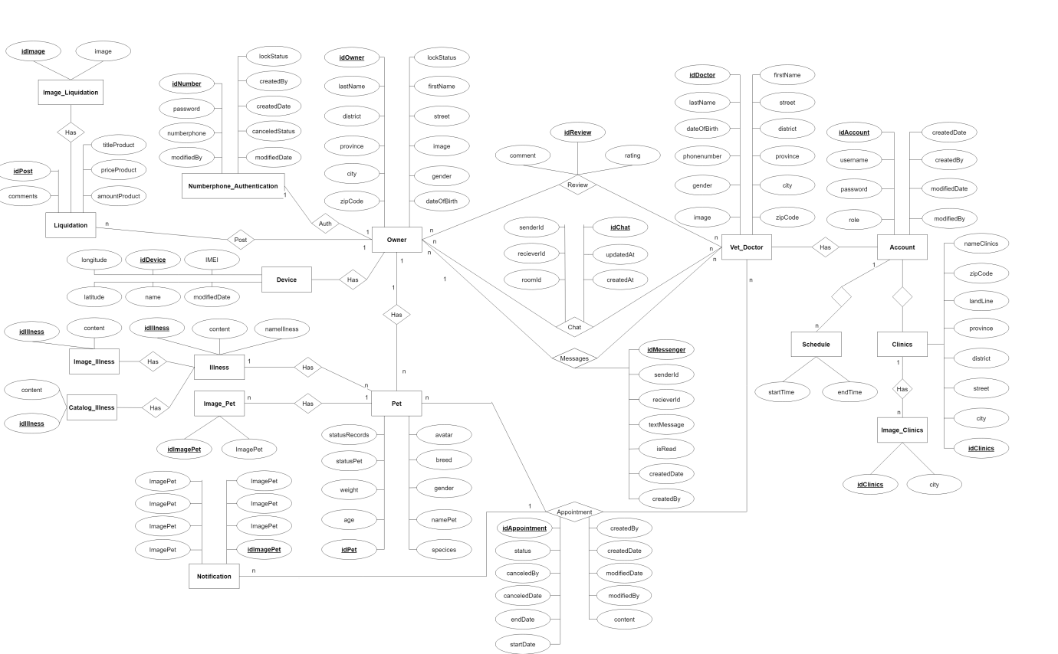

Relationship Diagram
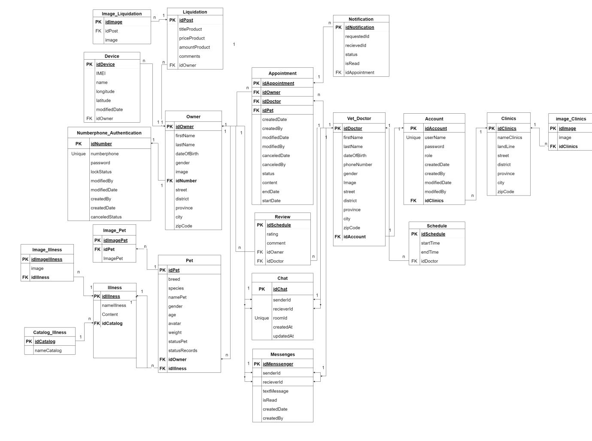
    - Numberphone_Authentication
Numberphone_Authentication
Field | Type | Constraint | Nullable | Description
idNumber | ObjectId | PK | No | Number id is primary key to specific unique row
Numberphone | String | Unique | No | Number phone data
Password | String |  | No | Password data
lockStatus | Boolean |  | No | lockStatus data
modifiedBy | String |  | No | Account modified data
modifiedDate | Date |  | No | Date of Account modified data
createdBy | String |  | No | Account created data
createdDate | Date |  | No | Date of account created data
cancedledStatus | Number |  | No | canceledStatus data

    - Owners
Owners
Field | Type | Constraint | Nullable | Description
idOwner | ObjectId | PK | No | Owner id is primary key to specific unique row
firstName | String |  | No | First name data
lastName | String |  | No | Last name data
dateOfBirth | Date |  | No | Date of birth data
Gender | String |  | No | Gender data
Image | String |  | No | Image url data
idNumber | ObjectId | FK | No | Number id is the foreign key and is the primary key of the Numberphone_Authentication
Street | String |  | No | Street data
District | String |  | No | District data
Province | String |  | No | Province data
City | String |  | No | City data
zipCode | String |  | No | Zipcode data

    - Clinics
Clinics
Field | Type | Constraint | Nullable | Description
idClinics | ObjectId | PK | No | Clinic id is primary key to specific unique row
nameClinic | String |  | No | Name of clinic data
landLine | String |  | No | Land line data.
Street | String |  | No | Street data
District | String |  | No | District data.
Province | String |  | No | Province data.
City | String |  | No | City data
zipCode | String |  | No | Zipcode data.

    - Image_Clinics
Image_Clinics
Field | Type | Constraint | Nullable | Description
idImage | ObjectId | PK | No | Image id is primary key to specific unique row
Image | String |  | No | Image URL data.
idClinics | ObjectId | FK | No | Clinics id is the foreign key and is the primary key of the Clinics

    - Accounts
Accounts
Field | Type | Constraint | Nullable | Description
idAccount | ObjectId | PK | No | Account id is primary key to specific unique row
Username | String | Unique | No | Username data.
Password | String |  | No | Password data.
Role | String |  | No | Role data.
createdDate | Date |  | No | Created Date data.
Createdby | String |  | No | Created by data.
modifiedDate | Date |  | No | Modified date data
modifiedBy | String |  | No | Modified by data
idClinics | ObjectId | FK | No | Clinics id is the foreign key and is the primary key of the Clinics

    - Vet_Doctos
Vet_Doctors
Field | Type | Constraint | Nullable | Description
idDoctor | Object | PK | No | Doctor id is primary key to specific unique row
firstName | String |  | No | First name data.
lastName | String |  | No | Last name data.
dateOfBirth | Date |  | No | Data of birth data.
phoneNumber | String |  | No | Phone number data.
Gender | String |  | No | Gender data.
Image | String |  | No | Image URL data.
Street | String |  | No | Street data.
District | String |  | No | District data.
Province | String |  | No | Province data.
City | String |  | No | City data.
zipCode | String |  | No | Zipcode data.
idAccount | ObjectId |  | No | Account id is the foreign key and is the primary key of the Account

    - Appointments
Appointments
Field | Type | Constraint | Nullable | Description
idOwner | ObjectId | FK | No | Owner id is the foreign key and is the primary key of the Owner
idDoctor | ObjectId | FK | No | Doctor id is the foreign key and is the primary key of the Vet_Doctor
idPet | ObjectId | FK | No | Pet id is the foreign key and is the primary key of the Pets
startDate | Date |  | No | Start Date data.
endDate | Date |  | No | End Date data.
Content | String |  | Yes | Content data
createdDate | Date |  | No | Created date data.
createdBy | String |  | No | Created by data.
modifiedDate | Date |  | No | Modifed date data.
modifiedBy | String |  | No | Modified by data.
canceledDate | Date |  | No | Canceled date data.
canceledBy | String |  | No | Canceled by data.
Status | String |  | No | Status data.

    - Catalog_Illness
Catalog_Illness
Field | Type | Constraint | Nullable | Description
idCatalog | ObjectId | PK | No | Catalog id is primary key to specific unique row
nameCatalog | String |  | No | Name of Catalog data.

    - Illness
Illness
Field | Type | Constraint | Nullable | Description
idIllness | ObjectId | PK | No | Illness id is primary key to specific unique row
nameIllness | String |  | No | Name of illness data.
Content | String |  | No | Content data.
idCatalog | ObjectId | FK | No | Catalog id is the foreign key and is the primary key of the Catalog_Illness

    - Image_Illness
Image_Illness
Field | Type | Constraint | Nullable | Description
idImageIllness | ObjectId | PK | No | Image Illness id is primary key to specific unique row
Image | String |  | No | Image URL data.
idIllness | ObjectId | FK | No | Illness id is the foreign key and is the primary key of the Illness

    - Pets
Pet
Field | Type | Constraint | Nullable | Description
idPet | ObjectId | PK | No | Pet id is primary key to specific unique row
breed | String |  | No | Breed data.
species | String |  | No | Species data.
namePet | String |  | No | Name of Pet data.
gender | String |  | No | Gender data.
Age | Number |  | No | Age data.
Weight | Number |  | No | Weight data.
statusPet | String |  | No | Status of pet data.
statusRecord | String |  | No | Status records data.
idOwner | ObjectId | FK | No | Owner id is the foreign key and is the primary key of the Owner
idIllness | ObjectId | FK | No | Illness id is the foreign key and is the primary key of the Illness

    - Review
Review
Field | Type | Constraint | Nullable | Description
idReview | ObjectId | PK | No | Review id is primary key to specific unique row
idOwner | ObjectId | FK | No | Owner id is the foreign key and is the primary key of the Owner
idDoctor | ObjectId | FK | No | Doctor id is the foreign key and is the primary key of the Doctor
rating | Number |  | No | Rating data.
comment | String |  | No | Comment data

    - Messages
Messages
Field | Type | Constraint | Nullable | Description
idMessenges | ObjectId | PK | No | Messenger id is primary key to specific unique row
recieverId | String |  | No | Receiver id is the foreign key and is the primary key of the account and the number phone
senderId | String |  | No | sender id is the foreign key and is the primary key of the account and the number phone
textMessage | String |  | No | Text message data.
createdDate | Date |  | No | Created Data data.
createdBy | String |  | No | Created by data.

    - Notification
Notification
Field | Type | Constraint | Nullable | Description
idNotification | ObjectId | PK | No | Notification id is primary key to specific unique row
idAppointment | ObjectId | FK | No | Appointment id is the foreign key and is the primary key of the Appointment
recieverId | String |  | No | Receiver id is the foreign key and is the primary key of the account and the number phone
senderId | String |  | No | sender id is the foreign key and is the primary key of the account and the number phone
Status | String |  | No | Status data.
Content | String |  | No | Content data.
isRead | Boolean |  | No | Is Read data.
createdDate | Date |  | No | Created Date data
createdBy | String |  | No | Created by data

    - Schedule
Schedule
Field | Type | Constraint | Nullable | Description
idSchedule | ObjectId | PK | No | Schedule id is primary key to specific unique row
startTime | Date |  | No | Start time data.
endTime | Date |  | No | End time data.
idDoctor | ObjectId | FK | No | Doctor id is the foreign key and is the primary key of the Doctor .

    - Chat
Chat
Field | Type | Constraint | Nullable | Description
idChat | ObjectId | PK | No | Chat id is primary key to specific unique row
recieverId | String |  | No | Receiver id is the foreign key and is the primary key of the account and the number phone
senderId | String |  | No | sender id is the foreign key and is the primary key of the account and the number phone
roomId | String | Unique | No | Room id data.
createdDate | Date |  | No | Created Data data.
createdBy | String |  | No | Created by data.

2.3.17. Liquidation
Liquidation
Field | Type | Constraint | Nullable | Description
idPost | ObjectId | PK | No | Liquidation id is primary key to specific unique row
titleProduct | String |  | No | Title product data
priceProduct | Number |  | No | Price product data
amountProduct | Number |  | No | Amount product data
commentProduct | String |  | No | Comment product data
idOwner | ObjectId | FK | No | Owner id is the foreign key and is the primary key of the Owner.

    - Image liquidation
Image Liquidation
Field | Type | Constraint | Nullable | Description
idImage | ObjectId | PK | No | Image id is primary key to specific unique row
idPost | ObjectId | FK | No | Post id is the foreign key and is the primary key of the Post.
image_product | String |  | No | Image product data

    - Device
Device
Field | Type | Constraint | Nullable | Description
idDevice | ObjectId | PK | No | Device id is primary key to specific unique row
IMEI | String |  | Yes | IMEI data
Name | String |  | No | Name of device data
Latitude | String |  | Yes | Latitude of device data
Longitude | String |  | Yes | Longitude of device data
modifiedDate | Date |  | Yes | Modifed Date of device data
idOwner | ObjectId | FK | Yes | Owner id is the foreign key and is the primary key of the Owner.

References

